**A LIVE PROJECT REPORT**

**on**

***“chatbot in nodejs”***

**Submitted in partial fulfilment of the requirements for the IP**

**BY**

**“Vikas Mandal”**

**TABLE OF CONTENTS**

|  |  |  |
| --- | --- | --- |
| S. No. | Topic | Page No |
| 1. | Introduction | 3 |
|  | 1.1 Motivation | 3 |
|  | 1.2 Objective | 3 |
|  | 1.3 Accessibility | 3 |
|  | 1.4 Technology Used | 3-4 |
| 2. | Working / Algorithm | 5 |
| 3. | Design/Architecture | 6-7 |
| 4. | Results | 8-9 |
| 5. | Refrences | 10 |

## Introduction

**1.1** **Motivation**

Over the years, Cloud Counselage has been on a mission to develop and groom freshers and professionals PAN India to become IT and Management pioneers. To accomplish this mission, we have Started Interships Program(IP) in Various Departments for the interns. But are interns are facing some doubts during the Internship Program(IP) phase, To clear the doubts regarding the Internship Program (IP), we have a FAQ page which answers almost all the frequently asked questions by the interns. Searching for a query and answer from the list of the Q&A is time consuming. As a solution we must come up with a solution which helps the interns to quickly find the answer for their queries.

## 1.2 Objective

The aim to overcome the present situation is to Build a chatbot using NodeJS.

## 1.3 Minimize workload

The Chatbot System is designed in such a way that it reduces the time Consumption in search of Frequently Asked Q&A by the intern . One of the main objective is to create an error free Chatbot system that correctly Answers the Questions on the basis of Input Given by the Interns . Therefore, this FAQ Chatbot Will help the interns to clear there Doubts.

## 1.4 Accessibility

These Chatbot System can be accessed by all Department Interns.

To ensure help to the user 24X7.

**1.5 Technology Used**

Node.js: Node.js is a cross-platform JavaScript runtime environment. It’s designed to build scalable network applications and can execute JavaScript code outside of a browser.The Server is Created using NodeJS to host the chatbot.

JavaScript is a client scripting language which is used for creating web pages. It is a standalone language developed in Netscape. It is used when a webpage is to be made dynamic and add special effects on pages like rollover, roll out and many types of graphics.Javascript is used to Develop Chatbot.

Html, Css And Different frameworks are used to create frontend for the chatbot and landing page for website.

**Working /Algorithm**

1. **On Landing Page Click On Faq Button.**

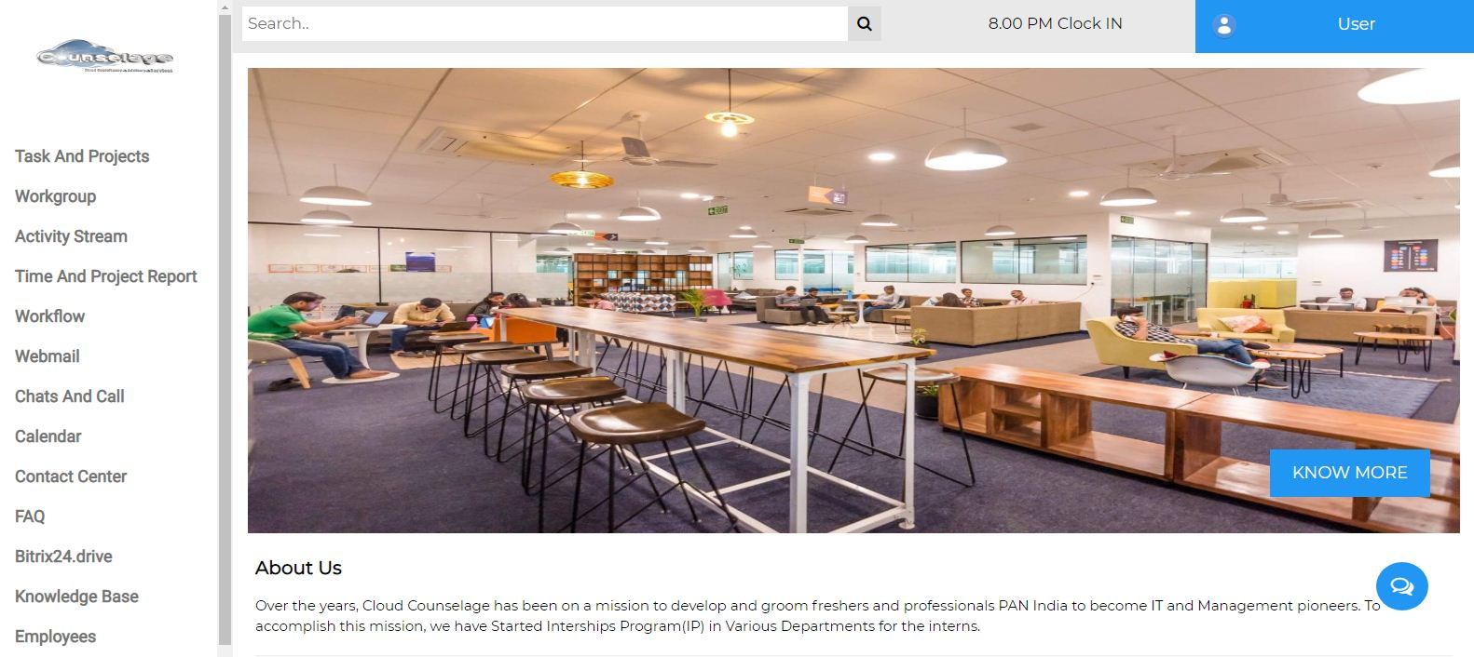

Click Here 🡪

1. **On chatbot Type hi/hello and select the phase of induction regarding which you have Queries and Corresponding With No. given .**

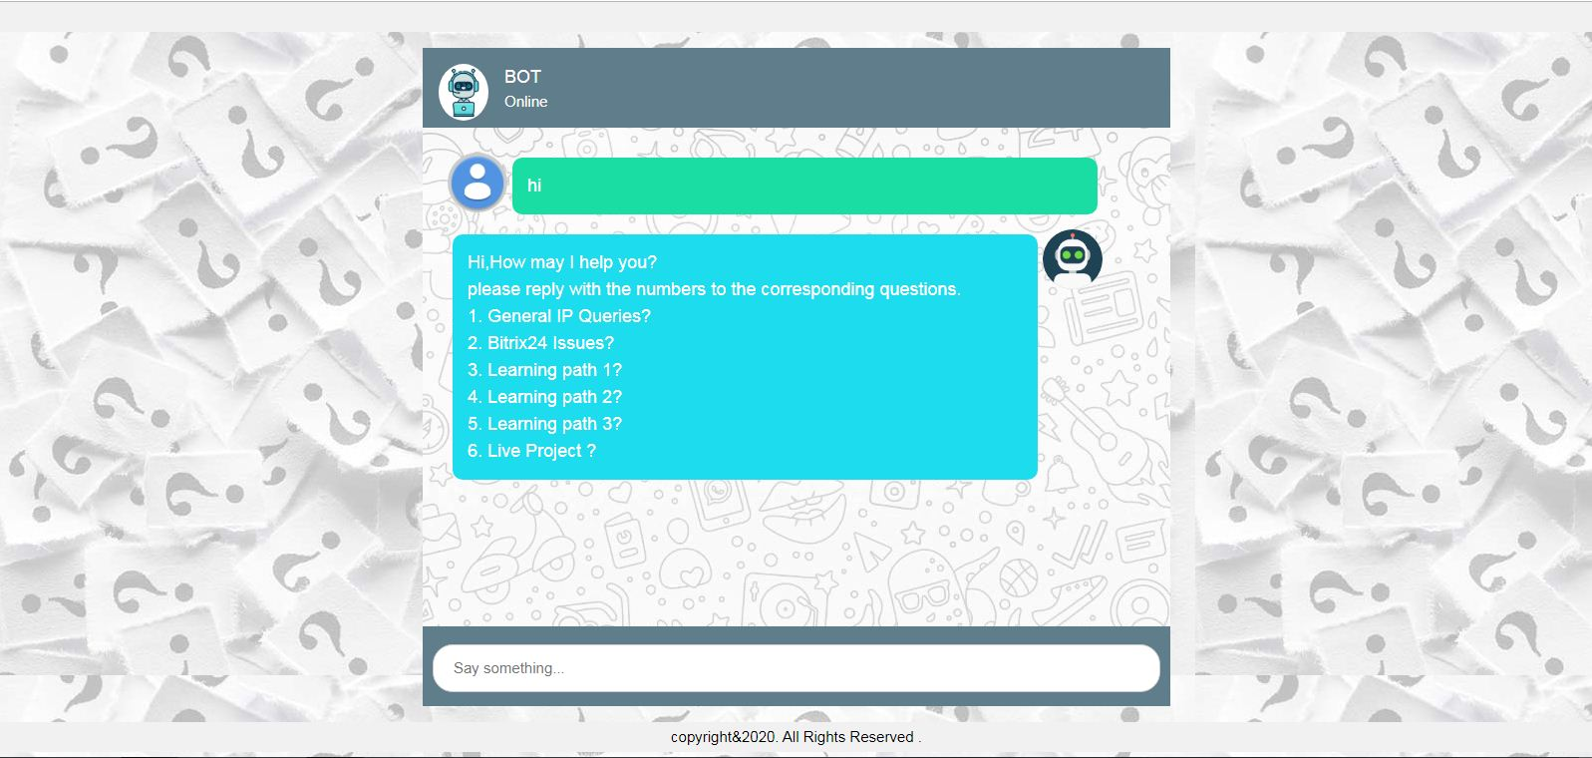

**Design/Architecture**

**Use Case Diagram**

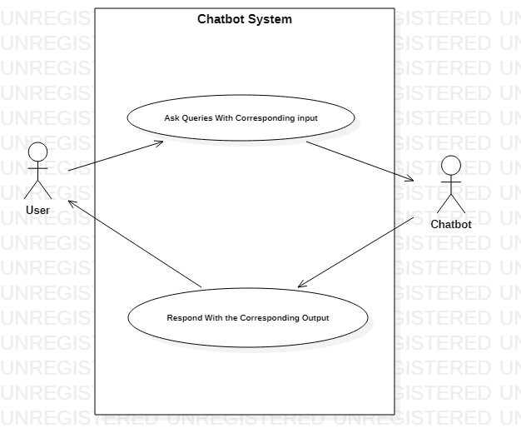

**Sequence Diagram**

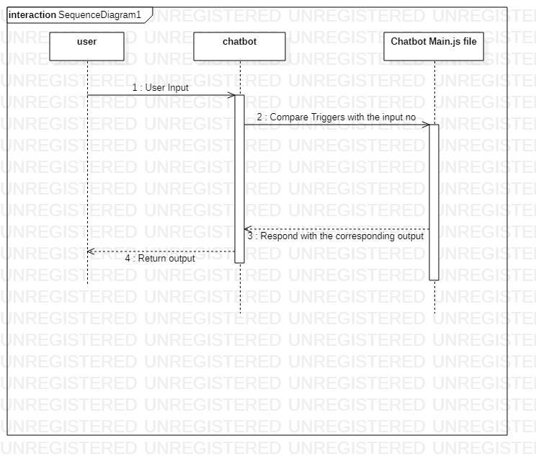

**Flowchart Diagram**

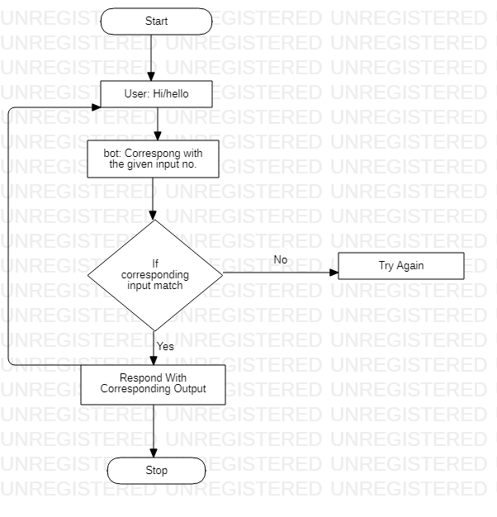

**Results**

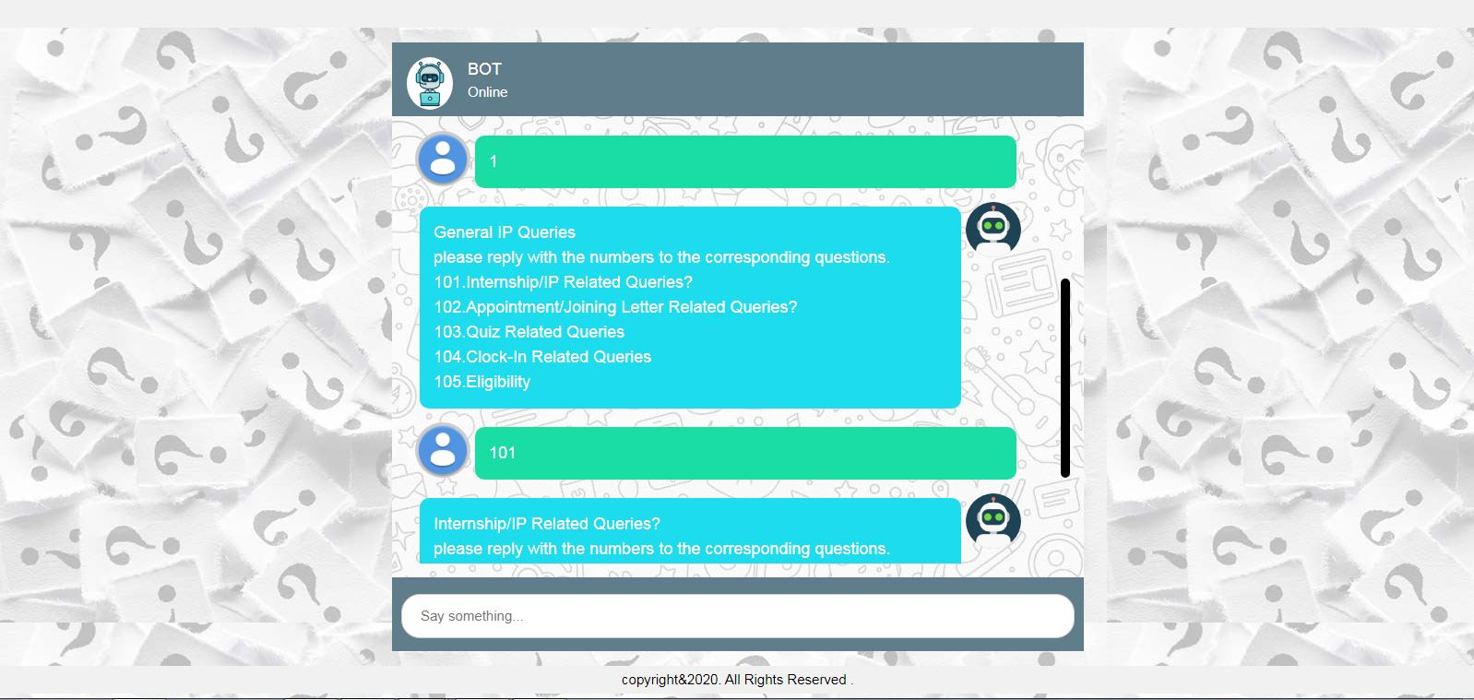

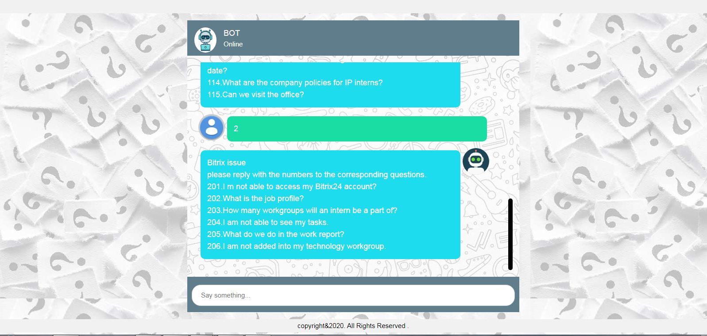

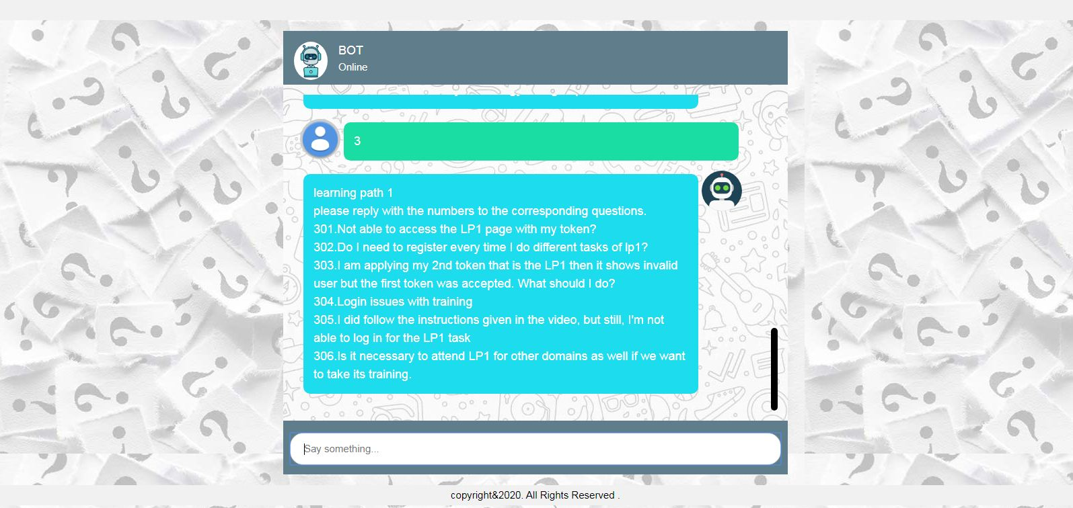

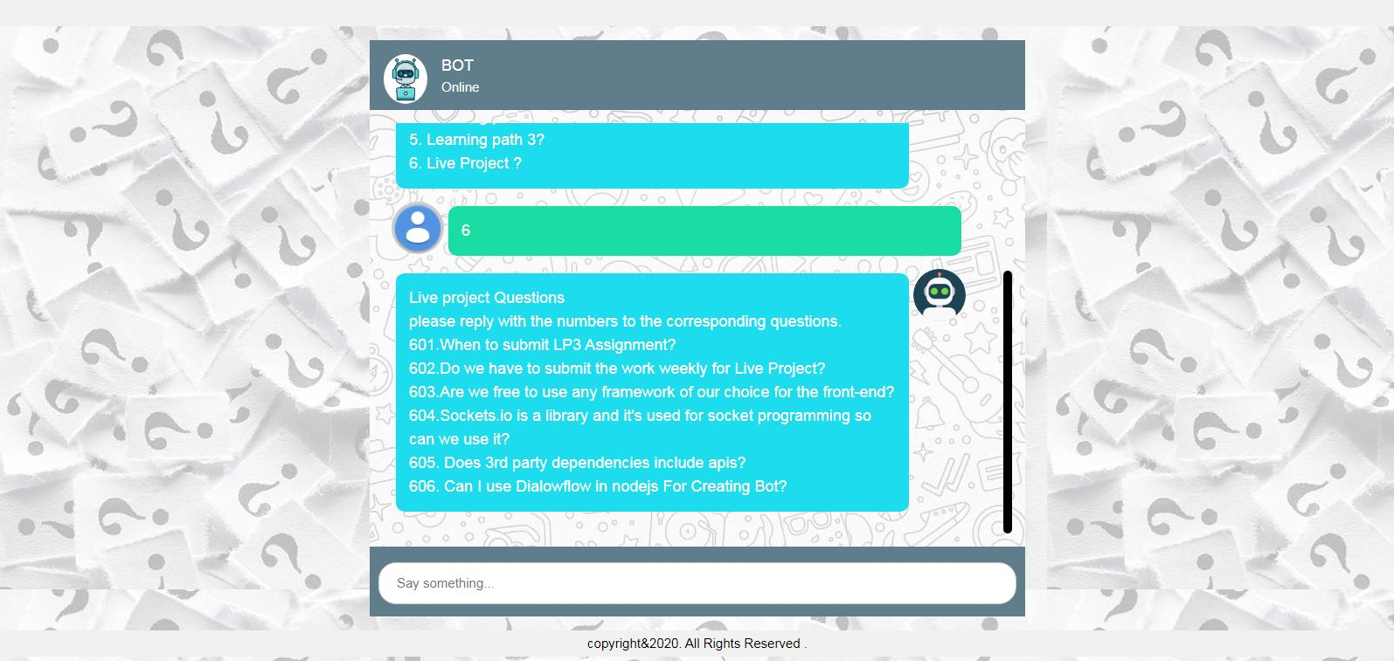

Refrences

* + - 1. [www.node.org](http://www.node.org)
      2. [www.w3school/html.com](http://www.w3school/html.com)
      3. [www.w3school/css.com](http://www.w3school/css.com)
      4. [www.w3school/javascript.com](http://www.w3school/javascript.com)